TUGAS PERTEMUAN 7 WEB AGNES PANJAITAN

<https://github.com/agneshagata/WebDSiangAgnes>

1. 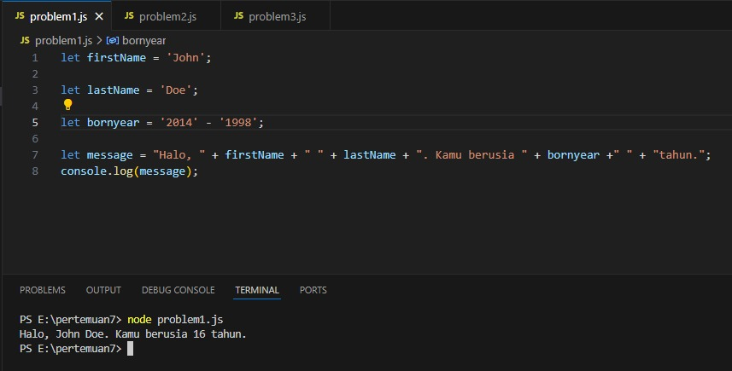

2. 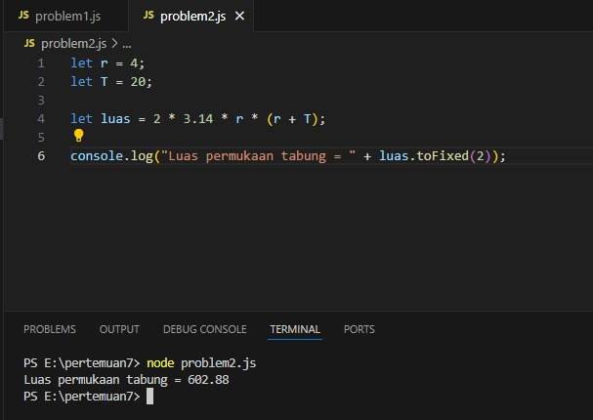

3. 